Magnetostatics Homework (30 Points)
(jas Magnetostatics HW.docx 11/09/2021)

Use units and clearly label answers using 3 or 4 significant digits where appropriate. Show your work so that if necessary partial credit can be awarded.

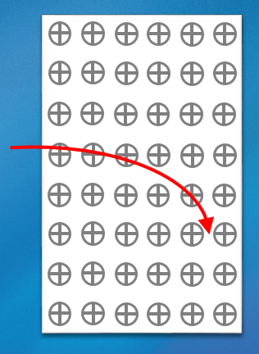
- The adjacent diagram shows in red the motion of a charged particle under the influence of a stationary magnetic field that is pointing into the page, away from the viewer. Choose the best answer for the charge polarity of the moving charged particle.
(2 points.)

- Positive.
- Negative.
- Neutral.
- Not enough information.

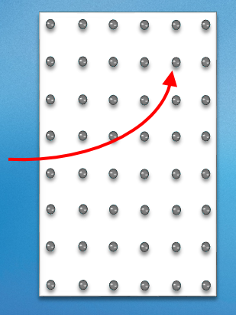
- The adjacent diagram shows in red the motion of a charged particle under the influence of a stationary magnetic field that is pointing out of the page towards the viewer. Choose the best answer for the charge polarity of the moving charged particle.
(2 points.)

- Positive.
- Negative.
- Neutral.
- Not enough information.

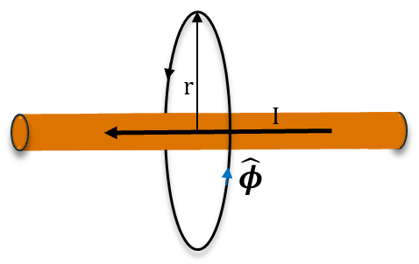
- The adjacent long narrow wire surrounded by air is carrying a dc current of 1 A. Calculate the magnitude of the magnetic flux density |B | at a radial distance of 50 cm from the center of a wire, far from the ends of the wire. (Hint: Answer should be somewhere between 300 and 500 nT.)
(3 Points.)
$$B=μH=\hat{ϕ}\frac{μI}{2πr};\left|B\right|=\frac{μ_{0}μ_{r}I}{2πr}=\frac{\left(4π*{10}^{-7}H/m\right)\left(1\right)\left(1A\right)}{2π(50*{10}^{-2}m)}=400 nT$$
$$B=400 nT$$

- Calculate the magnitude of the magnetic flux density |B | for an air core solenoid of length 2 cm with 3184 turns for a 0.25 A coil current. (Hint: Answer should be somewhere between 0.04 and 0.06 T.) (3 Points.)
$$B=\hat{z}\frac{μNI}{l};\left|B\right|=\frac{μ_{0}μ_{r}NI}{l}=\frac{\left(4π*\frac{{10}^{-7}H}{m}\right)\left(1\right)\left(3184\right)\left(0.25A\right)}{2*{10}^{-2}m}=0.05T$$
$$B=0.05 T$$

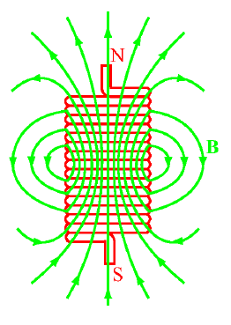
- A 4 cm long tightly wound air core solenoid with negligible wire diameter thickness has a cross-sectional diameter of 1 cm and a self-inductance of 1.25 mH. Using the self-inductance of a solenoid relationship
$L=\frac{μ_{0}μ_{r}N^{2}S}{length}\text{ (H)}$, calculate N, the number of turns of wire this solenoid has? (Hint: Answer should be somewhere between 700 and 800 turns). (6 points.)
$$N=\sqrt{\frac{L\left(l\right)}{μ_{0}μ_{r}S}}=\sqrt{\frac{\left(1.25*{10}^{-3}H\right)\left(4*{10}^{-2}m\right)}{\left(4π*\frac{{10}^{-7}H}{m}\right)\left(1\right)\left(π{\left(0.5*{10}^{-2}\right)}^{2}\right)}}=711.76 Turns$$
$$N=711.76 Turns$$

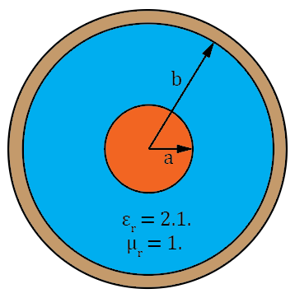
- Given a coaxial cable with a center conductor diameter of 2.3 mm and an inside diameter of 7.7 mm for the outer conductor, along with a relative permittivity of 2.1 and a relative permeability 1 for the dielectric between conductors determine each of the following:

- Calculate the inductance per unit length in (H/m) of the coaxial cable. (3 points.)
$$L^{'}=\frac{μ}{2π}\ln\left(\frac{b}{a}\right)=\frac{μ_{0}μ_{r}}{2π}\ln\left(\frac{b}{a}\right)=\frac{(4π*{10}^{-7}H/m)(1)}{2π}\ln\left(\frac{7}{2.3}\right)=220 nH/m$$
$$L^{'}=220 nH/m$$
- Calculate the capacitance per unit length in (F/m) of the coaxial cable. (3 points.)
$$C^{'}=\frac{2πϵ}{\ln\left(\frac{b}{a}\right)}=\frac{2π\left(8.85*\frac{{10}^{-12}F}{m}\right)(2.1)}{\ln\left(\frac{7}{2.3}\right)}=105 pF/m$$
$$C^{'}=105 pF/m$$
- Calculate the characteristic impedance of the coaxial cable, assuming R’ and G’ equal zero, i.e. a lossless transmission line. (Hint: Z₀ should be between 40 Ω and 60 Ω.)
(2 points.)
$$Z_{0}=\sqrt{\frac{L^{'}}{C^{'}}}=45.77 Ω$$
$$Z_{0}=45.77 Ω$$

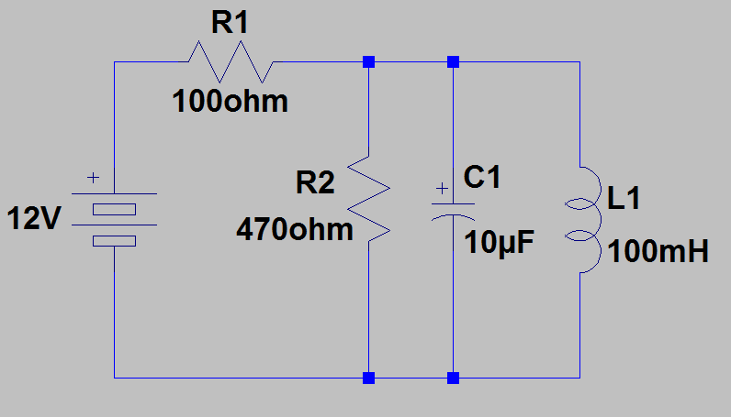
- Calculate the total energy stored in the ideal inductor and capacitor of the adjacent DC circuit. (Hint: Answer should be somewhere between 680 and 750 µJ.) (3 Points.)
$$W_{C}=\frac{1}{2}CV^{2}; W_{L}=\frac{1}{2}LI^{2}$$
$$W_{L}=\frac{1}{2}\left(100*{10}^{-3}H\right){\left(\frac{12V}{100Ω}\right)}^{2}=720 μJ$$
$$W_{T}=720 μJ$$
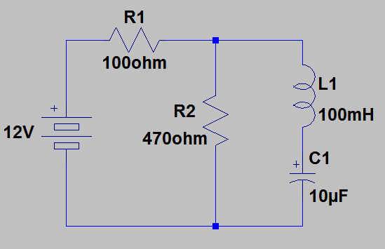
- Calculate the total energy stored in the ideal inductor and capacitor of the adjacent DC circuit. (Hint: Answer should be somewhere between 450 and 500 µJ.) (3 Points.)
$$W_{C}=\frac{1}{2}CV^{2}; W_{L}=\frac{1}{2}LI^{2}$$
$$W_{C}=\frac{1}{2}\left(10*{10}^{-6}F\right){\left(\frac{470}{570}*12V\right)}^{2}=489.5 μJ$$
$$W_{C}=489.5 μJ$$

